 | November 2023
Sun | Mon | Tue | Wed | Thu | Fri | Sat
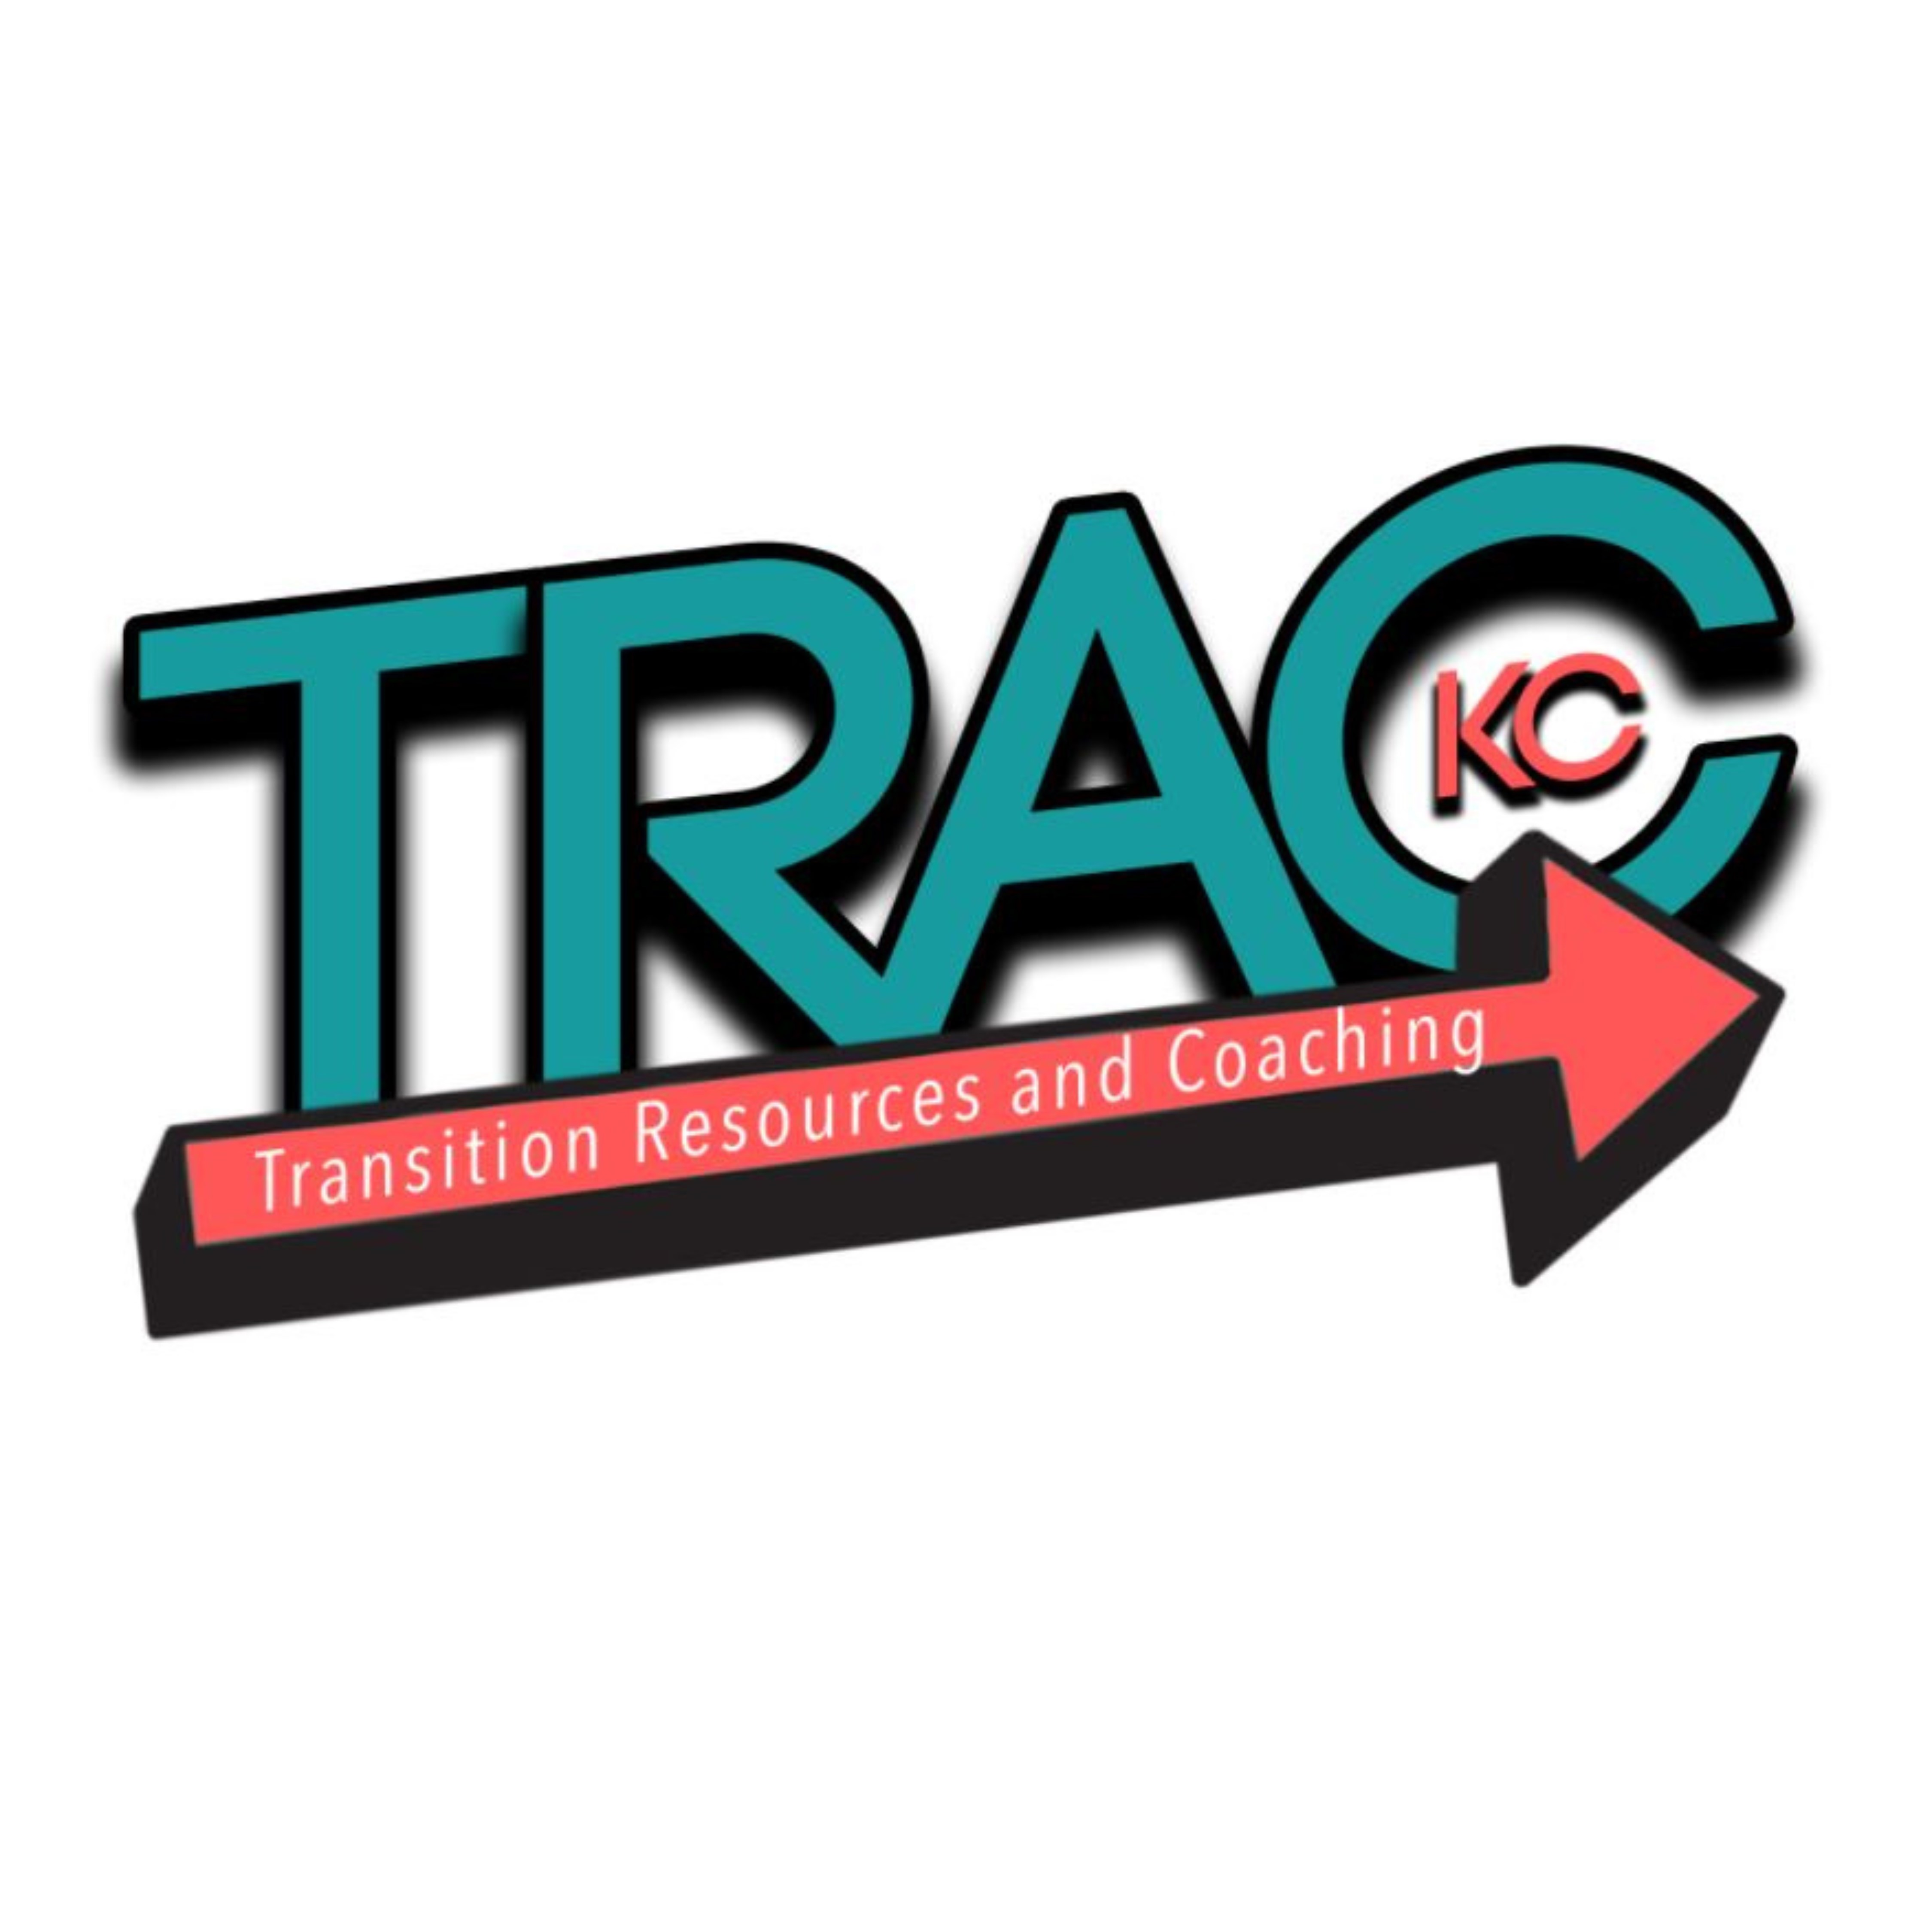 |  |  | 1 | 2  Life Skills  6:30pm-7:45pm  Kitchen Skills 1 of 6  Church of the Resurrection, OP  $180 for 6 sessions | 3 | 4
5  Basketball Clinic  2:00-3:30  LTD Training Center  $30  Daylight Savings Time Ends | 6 | 7  Election Day | 8 | 9  Life Skills  6:30pm-7:45pm  2 of 6  Church of the Resurrection, OP | 10 | 11  Veterans Day
12 | 13 | 14 | 15 | 16  Life Skills  6:30pm-7:45pm  3 of 6  Church of the Resurrection, OP | 17 | 18  Self-Defense Class  10:00am-noon  Blue Valley Recreation  12500 Switzer Rd  $25
19 | 20 | 21 | 22 | 23  Thanksgiving Day | 24 | 25
26 | 27 | 28 | 29 | 30  Life Skills  6:30pm-7:45pm  4 of 6  Church of the Resurrection, OP  [Will continue thru Dec 14th; Dec 21st—potential make-up day] | To sign up for classes or activities, go to our Registration page at trac-kc.org!  Questions? Email us at trac.in.kc@gmail.com

